**Difference Between Black Box testing and White box testing**

Black Box Testing White Box Testing

|  |  |
| --- | --- |
| Black box testing is a software testing method in which the internal structure/design and implementation of the item being tested is not known to the tester. | White box testing is a software testing method in which the internal structure/design/implementation of the item being tested is known to the tester. |
| Only the external design and structure are tested | Implementation and impact of the code are tested |
| It is mostly done by software tester | It is mostly done b software devolper. |
| It is functional test of the software | It is the structural test of the software |
| Black box testing technique  1.dcision tabletesting  2.all pairs testing  3.equivalance  4.error | White box ttesting technique  1.control flow testing  2.data flow  3.branch |

**Differance between verification and validation**

|  |  |  |
| --- | --- | --- |
| **Varification** | **Validation** | |
| Verification is the static testing. | |  | | --- | | Validation is the dynamic testing. | |  | | |
| It does not include the execution of the code. | |  | | --- | | It includes the execution of the code. | | |
| It is also known as static testing, where we are ensuring that "**we are developing the right product** | Validation testing is also known as dynamic testing, where we are ensuring that **"we have developed the product right."** | |
| **Quality assurance** comes under verification testing. | |  | | --- | | Quality control comes under validation testing. | |  | | |
| The execution of code does not happen in the verification testing. | |  | | --- | | In validation testing, the execution of code happens. | |  | | |
| In verification testing, we can find the bugs early in the development phase of the product. | |  | | --- | | In the validation testing, we can find those bugs, which are not caught in the verification process. | |  | | |
| Verification testing is executed by the Quality assurance team to make sure that the product is developed according to customers' requirements. | |  | | --- | | Validation testing is executed by the testing team to test the application. | |  | | |
| Verification is done before the validation testing. | | |  | | --- | | After verification testing, validation testing takes place. | |  | |
| In this type of testing, we can verify that the inputs follow the outputs or not. | | In this type of testing, we can validate that the user accepts the product or not. |

**Grey Box Testing** -Gray box testing is a software testing technique to test a software product or application with partial knowledge of internal structure of the application. The purpose of grey box testing is to search and identify the defects due to improper code structure or improper use of applications.

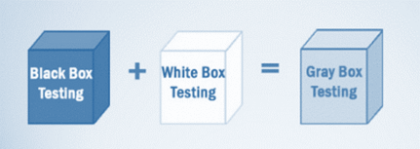

Gray Box Testing

Gray box testing is combination of White Box Testing and Black Box Testing.

**There are Four Technique are :**

**Matrix Testing:**This testing technique involves defining all the variables that exist in their programs.

**Regression Testing**: To check whether the change in the previous version has regressed other aspects of the program in the new version. It will be done by testing strategies like retest all, retest risky use cases, retest within a firewall.

**Orthogonal Array Testing or OAT**: It provides maximum code coverage with minimum test cases.

**Pattern Testing:** This testing is performed on the historical data of the previous system defects. Unlike black box testing, gray box testing digs within the code and determines why the failure happened

Software maintenance is an activity which includes enhancements, error corrections, optimization and deletion of existing features. These modifications may cause the system to work incorrectly. Therefore, Regression Testing becomes necessary. Regression Testing can be carried out using the following techniques:

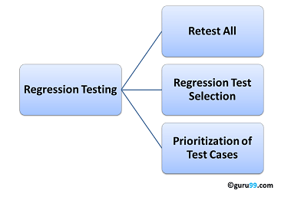

**Retest All**

This is one of the methods for Regression Testing in which all the tests in the existing test bucket or suite should be re-executed. This is very expensive as it requires huge time and resources.

**Regression Test Selection**

Regression Test Selection is a technique in which some selected test cases from test suite are executed to test whether the modified code affects the software application or not. Test cases are categorized into two parts, reusable test cases which can be used in further regression cycles and obsolete test cases which can not be used in succeeding cycles.

**Prioritization of Test Cases**

Prioritize the test cases depending on business impact, critical & frequently used functionalities. Selection of test cases based on priority will greatly reduce the regression test suite.